IIA ASSIGNMENT 3 THEORY

Q#1. Refer to the exhibit. R1 was configured with the static route command ip route 209.165.200.224 255.255.255.224 S0/0/0 and consequently users on network [172.16.0.0/16](https://www.google.com/url?q=http://172.16.0.0/16&sa=D&ust=1589724195796000&usg=AFQjCNE3AIzUbt0Ef3F2Xpaq9QfquyANjA) are unable to reach resources on the Internet. How should this static route be changed to allow user traffic from the LAN to reach the Internet?



Your answer

Refer to Question#1

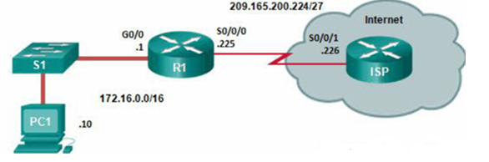

Q#2. Refer to the exhibit. All hosts and router interfaces are configured correctly. Pings to the server from both H1 and H2 and pings between H1 and H2 are not successful. What is causing this problem?



Your answer

Refer to Question#2

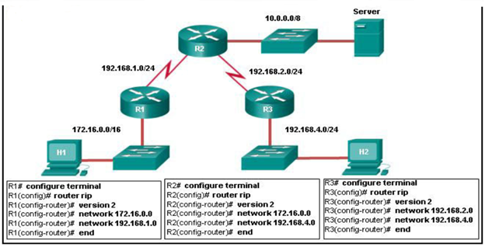

Q#3Which formula ospf used for calculating Cost by using Bandwidth as a metric



Your answer

Q#4 Highlight different types of routers, mentioned with router name as available in diagram



Your answer

Refer to Question#4

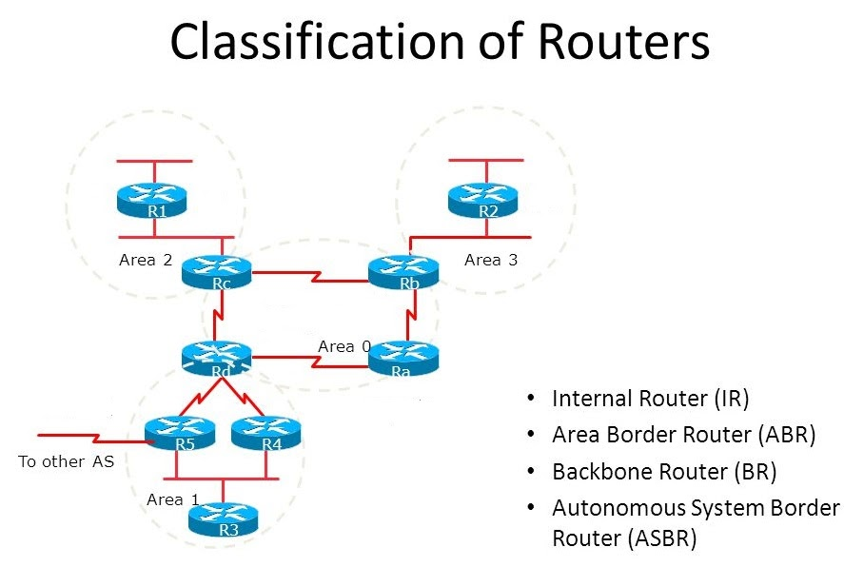

Q#5. What does Hello packet contains?



Your answer